USGS Pennsylvania Water Science Center
1000 Church Hill Road, Suite 200
Pittsburgh, Pennsylvania 15205
(412) 490-3806 FAX (412) 490-3828

Date: October 21, 2010

To: Janice Fulford, Chief, Testing Section, Hydrologic Instrumentation Facility, Stennis Space
Center, MS

Through: Bob Hainly, Associate Director, USGS PAWSC, New Cumberland, PA

From: John Fulton, Hydrologist, USGS PAWSC, Pittsburgh, PA
Mallori McDowell, Hydrologic Technician, USGS PAWSC, Pittsburgh, PA

Subject: Benchmarking the Stalker Pro II Surface Velocity Radar Gun

Background
The use of radar to measure surface-water velocity and streamflow during unsteady flow events may offer an alternative to conventional methods such as current meters and hydroacoustics. Bridge-mounted radar units are currently being tested by the U.S. Geological Survey (USGS); however, portable, handheld units offer efficiency, practicality and cost effectiveness. The USGS, Pittsburgh Project Office, Pennsylvania Water Science Center field-tested the Stalker Pro II Surface Velocity Radar (SVR, Any use of trade, product, or firm names in this document is for descriptive purposes only and does not imply endorsement by the U. S. Government) to evaluate its capabilities.

Objectives
The objectives of the field test were to benchmark the Stalker SVR against conventional instrumentation (FlowTracker Handheld-ADV® acoustic Doppler velocimeter, ADV; Teledyne RD Instruments 2.0 MHz StreamPro acoustic Doppler current profiler, ADCP) and compute streamflow based on the surface-water velocities acquired in the field.

Location
Chartiers Creek near Bridgeville, PA (USGS Station Number 03085290) is a stable stream, consisting of a 160-square mile (mi²) drainage area, and characterized by varied land use including wooded, open space, commercial, and residential (fig. 1).

The site is located near N40°19'54.0", W80°06'48.5" (referenced to North American Datum of 1983, Allegheny County, PA, Hydrologic Unit 05030101), is downstream of a bridge on Mayview Road, north of Mayview State Hospital, and is approximately 1.5 mi south of Bridgeville Borough. The streamgage was established by the USGS on March 23, 2004 and consists of a wire weight gage mounted on the downstream wall of the bridge.

Figure 1 Chartiers Creek at Bridgeville, Pennsylvania (N40°19'54.0", W80°06'48.5") referenced to North American Datum of 1983, Allegheny County, PA.

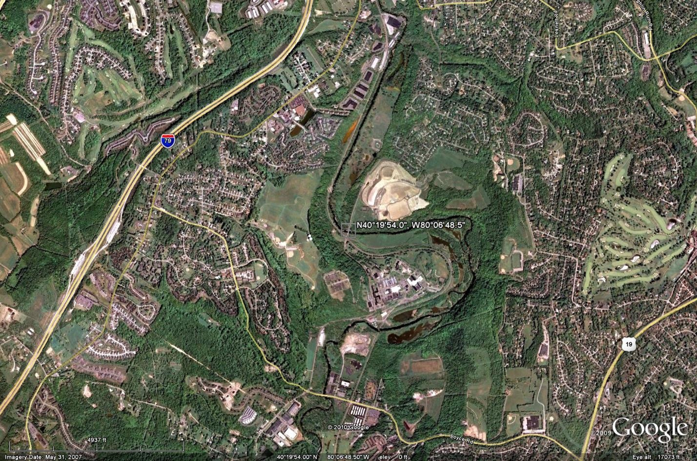

The channel is straight for approximately 400 ft upstream of the wire weight, with low sloping banks on both the right and left side of the stream consisting of cobble and silt and covered with brush. The channel meanders downstream with the first bend occurring approximately 100 ft downstream of the wire weight. The stream is controlled by the channel geometry. At high stage the water can over top the banks and fill the floodplain on the left bank of the stream; there is no floodplain on the right bank. The channel bed consists of cobble and silt.

Wading measurements can be made below a stage of about 3.0 ft in the section from the gage to 150 ft upstream. High water measurements can be made from the downstream side of the bridge with either a current meter or an ADCP.

Methods
A cross-section was established upstream of the bridge using a tag line (fig. 2), where channel geometry and hydraulic data were obtained. Channel geometry included water depth, area, and width and were measured using a range finder and ADCP. Hydraulic data included streamflow, surface-water velocity and point velocities and were measured using an ADCP, SVR, and ADV (fig. 3).

Streamflow was computed directly using an ADCP and indirectly using an SVR/ADV with entropy-based methods, which relies on surface-water and point velocities collected at the y-axis (the vertical where the maximum, instream velocity occurs).

Figure 2 View of the cross section during the testing, Chartiers Creek at Bridgeville, Pennsylvania, Allegheny County, PA.

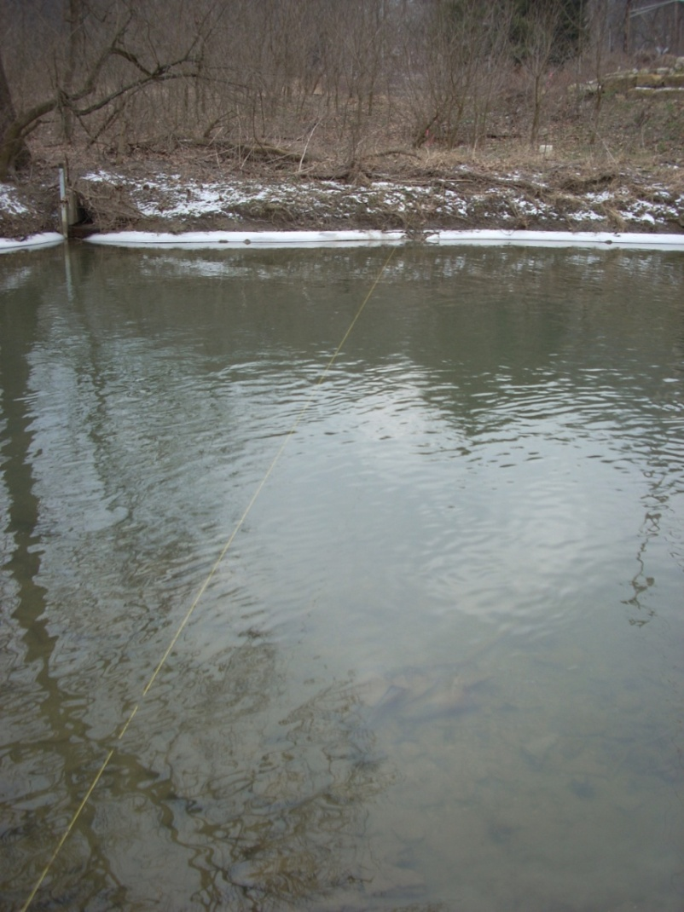

Figure 3 Types of streamflow measurements collected at Chartiers Creek at Bridgeville, Pennsylvania, Allegheny County, PA.
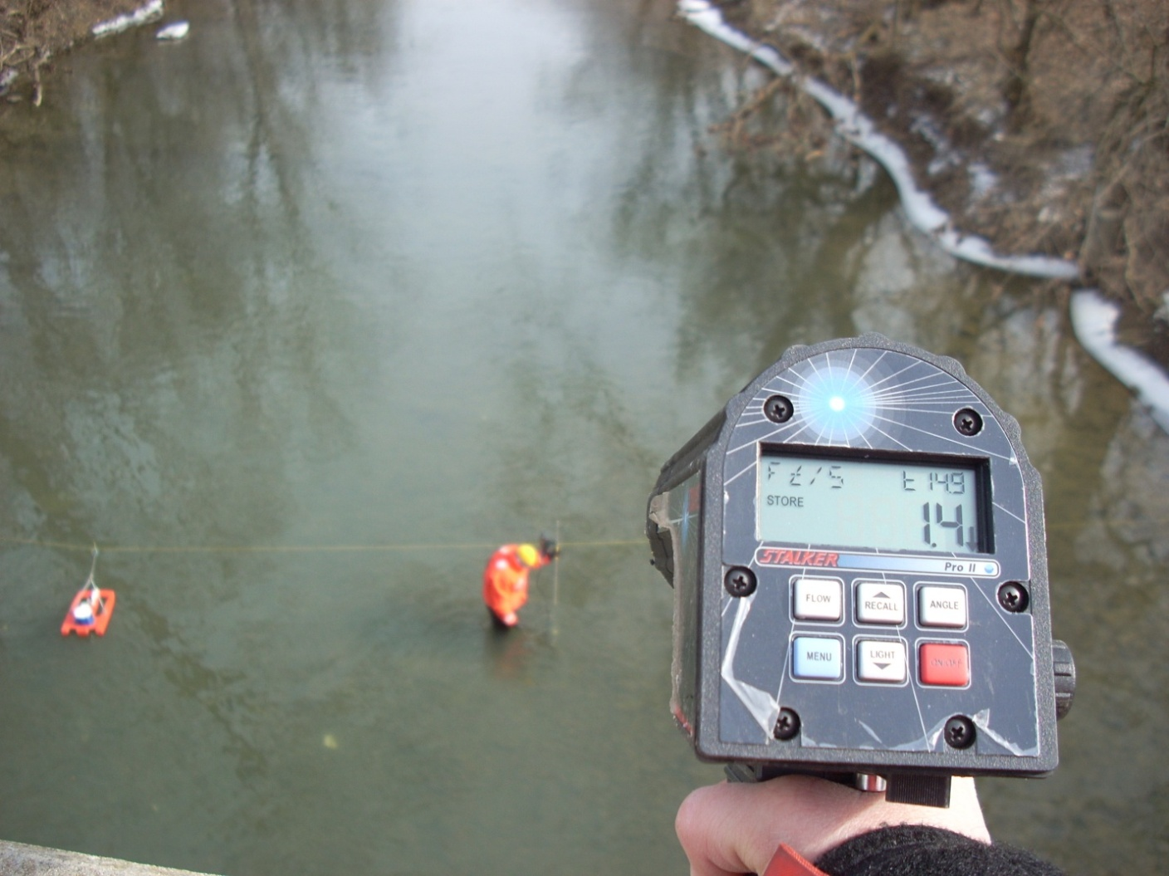

Findings
The first objective was to benchmark the SVR against traditional methods for measuring stream velocities in open channels. ADV data were used to establish the location of the maximum in-stream and surface-water velocity, respectively. Velocity profiles were measured along five verticals; the results are summarized in table 1. The profile measured at the y-axis (fig. 4) extends from the stream bed to near the water surface at .25 ft increments. Nonlinear regression was used to compute variables needed to estimate the instantaneous streamflow using information entropy.

Table 1 Velocity profiles at verticals recorded by the ADV from Chartiers Creek near Bridgeville, PA (03085290).
[fps, feet per second; ft, feet from the right waters edge; ADV, acoustic Doppler velocimeter; TD, total depth in ft and coincides with the water surface; --, not available]
Distance above channel bottom (ft) | Velocity (fps)
 | Station 28 | Station 32 | Station 36 | Station 40 | Station 44
.25 | .76 | .75 | .86 | .76 | .73
.50 | 1.28 | 1.14 | 1.36 | 1.04 | .95
.75 | 1.36 | 1.24 | 1.27 | 1.22 | 1.27
1.00 | 1.57 | 1.46 | 1.42 | 1.29 | 1.30
1.25 | 1.54 | 1.50 | 1.50 | 1.35 | 1.47
1.50 | 1.65 | 1.51 | 1.46 | 1.45 | 1.55
1.75 | 1.77 | 1.59 | 1.53 | 1.36 | 1.54
2.00 | 1.77 | 1.60 | 1.69 | 1.52 | 1.58
2.10 | 1.66 | 1.57 | 1.60 | 1.56 | TD
2.20 | TD | -- | -- | -- | --
2.25 | -- | TD | TD | TD | --

Figure 4 Velocity profile at Station 28, Chartiers Creek near Bridgeville, PA (03085290).
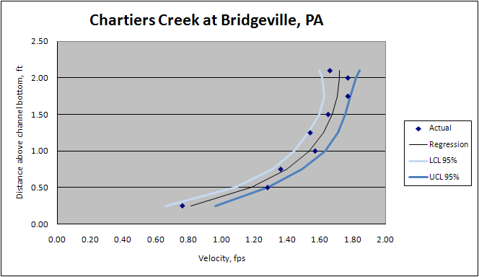
To validate the surface-water velocities recorded by the SVR, an ADV was used to measure the velocity near the water-air interface at selected verticals beginning at the right waters edge (RWE) and extending at regularly spaced intervals to the left waters edge (LWE) along the tag line (table 2).

Station 28, which is located approximately 28 ft from the RWE, reported the greatest in-stream point velocity (1.77 fps, table 1) and surface-water velocity (1.7 fps, table 2). Surface-water velocities reported for the SVR and ADV were compared and percent differences ranging from 0 to 8.3 percent were calculated (table 2). Because the ADV is intended to measure point velocities below the water surface, it offers only an estimate of the actual surface-water velocity. Differences may be attributed to (1) potential boundary layer problems imposed by the receiving arms of the ADV wading rod and (2) the sample area for the ADV (~3E-4 ft²) is considerably less than that for the SVR (~63 ft² assuming a beam angle of 12° from a bridge height of 30 ft). Because the SVR samples a significantly larger area, the measurement represents an average of the velocity variations, which may exist in the sample area.

Table 2 Surface-water velocities measured at verticals from Chartiers Creek near Bridgeville, PA (03085290).
[fps, feet per second; ft, feet from the right waters edge; RWE, right waters edge; ADV, acoustic Doppler velocimeter; SVR, surface-water velocity radar]

Stream | Station number from RWE (ft) | Surface-water velocity (fps) |  | % Difference
 |  | ADV | SVR
Chartiers Cr. Bridgeville | Station 28 | 1.66 | 1.7 | 2.4
Chartiers Cr. Bridgeville | Station 32 | 1.57 | 1.7 | 8.3
Chartiers Cr. Bridgeville | Station 36 | 1.60 | 1.6 | 0.0
Chartiers Cr. Bridgeville | Station 40 | 1.56 | 1.5 | 3.9
Chartiers Cr. Bridgeville | Station 44 | 1.58 | 1.5 | 5.1

The second objective was to measure streamflow directly using conventional methods such as an ADCP and indirectly using an SVR/ADV and a computational scheme based on information entropy. Four transects were measured using the ADCP. A stationary moving bed test was conducted to confirm or deny a moving bed existed at the site at the time of the measurement. The ambient-air temperature was 36.5° F. Average values for streamflow, width, and area are summarized in table 3.

Table 3 Summary of ADCP transect from Chartiers Creek near Bridgeville, PA (03085290).
[cfs, cubic feet per second; ft, feet from right waters edge or left waters edge; RWE, right waters edge; LWE, left waters edge; sf, square feet; Avg, average; SD, standard deviation]

Transect number | Start bank | Streamflow (cfs) | Width (ft) | Total area (sf)
3085290003 | LWE | 118.07 | 72.96 | 113.51
3085290004 | RWE | 119.05 | 72.88 | 111.46
3085290005 | LWE | 123.06 | 73.60 | 113.85
3085290006 | RWE | 124.79 | 73.91 | 112.71
 | Avg | 121.24 | 73.34 | 112.88
 | SD | 3.2 | 0.5 | 1.06

Streamflow data were collected and processed using WinRiver II, ver. 2.04. Average streamflow for the four transects was estimated at 122 cfs and characterized by a standard deviation of 3.2 cfs, suggesting little variation in the magnitude of streamflow associated with each transect. Total area was estimated at 113 sf with a standard deviation of 1 sf.

By comparison, the SVR/ADV measurements yielded streamflow values ranging from 121 to 149 cfs. Three methods were used to compute streamflow and included (1) no instream velocity data was required a priori, (2) point velocities were collected at the y-axis using an ADCP or ADV and plotted by depth above the channel bed to near the water surface, and (3) point velocities were fitted using a nonlinear form of a velocity profile; which is a function of the maximum velocity (u_{max}); its location below the water surface (h), above the channel bottom (y), and depth (D) at the y-axis; and a dimensionless variable (M) of the velocity distribution.

Table 4 Summary of ADCP transect from Chartiers Creek near Bridgeville, PA (03085290).
[ADCP; computed using the acoustic Doppler current profiler; cfs, cubic feet per second; ft, feet; fps, feet per second; sf, square feet; ft, feet]
Parameter | Definition | Value
Q_{ADCP} |  | 121 cfs
φ | u_{avg} / u_{max} = ( e ^{M} / e ^{M} – 1) – 1/M | .63
M | parameter relating the mean and maximum water velocities | 1.57
G(M) | (e ^{M} – 1)/Mφ | 3.87
u_{max} | maximum water velocity | 2.11 fps ¹  1.78 fps ²  1.72 fps ³
area | area | 113 sf
D | water depth at the y-axis | 2.2 ft
h/D | depth of u_{max} below the water surface; if h > 0, then u_{max} occurs below the water surface | .54 ¹  .32 ²  .18 ³
Q_{COMPUTED} |  | 149 cfs ¹  125 cfs ²  121 cfs ³
Note: | ¹ = no data collected a priori, where h/D = 0.54 = -2 ln(G(M)/58.3) and is derived from a theoretical solution based on Chiu and Tung (2002)  ² = point velocities were collected as a function of depth at the y-axis using an ADV and were plotted to determine h/D = 0.33  ³ = point velocities were collected as a function of depth at the y-axis using an ADV and nonlinear regression was used to determine h/D = 0.11

The results suggest that by collecting limited field data such as point velocities, water depth at the y-axis and channel area, percent differences between the computed and measured streamflow decreased significantly from 23 percent to -0.6 percent.

The two variables, which influence the surface-water velocities recorded by the SVR, are the air gap (the distance from the bridge deck to the water surface) and the quantity and quality of scatterers on the water surface. During periods of low turbulence (low surface-water velocities, little or no surface roughness) the quality of the return received by the SVR produced inconsistent surface-water velocity readings. This is particularly true near the waters edge, where surface-water velocities are relatively slower. The lowest surface-water velocity recorded during the field testing was 1.3 fps at a range of approximately 45 feet; the highest surface-water velocity recorded was 1.8 fps. In portions of the channel where the turbulence was sufficient to generate a return, the percent differences in the surface-water velocities measured by the SVR when compared to that reported by the ADV (near the water surface) at the same station ranged from 0 to 8.3 percent.

To better identify the operating range of the unit, additional testing under a controlled environment such as in a flume, is needed. The surface-water velocity and quantity and quality of the scatterers could be modified for various flow conditions that may be encountered in the field. In addition, supplemental field testing during high-flow periods at the site will be performed when conditions permit.

cc: Bill Fagan, Vice President Sales & Marketing, Applied Concepts, Inc.

